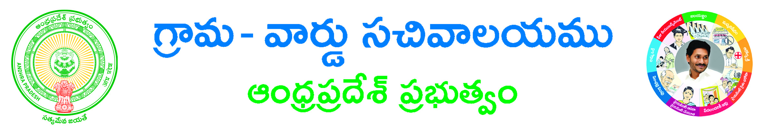**EPDCL Category Change Application Form**

Paste here your recent passport size photograph

**Service Change Type*: 🞏 Category Change**

**Service Connection Number*: ____________________________________________**

**Circle Name*: 🞏 Eluru 🞏 Rajahmundry 🞏 Srikakulam 🞏 Visakhapatnam 🞏 Vizianagaram**

**Area Code*: _____________________________ Section Name*: _________________________________**

**Consumer Details:-**

**Aadhar Number: ______________________ Consumer Name *: ___________________________________________ Consumer Surname*: __________________________ Consumer Father Name*: _____________________________________**

**Social Group *: 🞏 Others 🞏 S.C 🞏 S.T If Others: ____________________________________________________________**

**Actual Connection Type*: 🞏 Domestic 🞏 Commercial 🞏 Commercial – Hoardings 🞏 6A – Street Lights**

**🞏 6B – Public Water Works 🞏 General Issues**

**🞏 Religious Places (Temples, Church, Mosque, Govt.Schools etc)**

**Changing Connection Type*: 🞏 Domestic 🞏 Commercial 🞏 Commercial – Hoardings 🞏 6A – Street Lights**

**🞏 6B – Public Water Works 🞏 General Issues**

**🞏 Religious Places (Temples, Church, Mosque, Govt.Schools etc)**

**Location Type*: 🞏 Urban 🞏 Rural Location Name*: _________________________________________________**

**Location of Premises:-**

**House No*: ____________________Locality*: _________________________________________________________________**

**Circle*: 🞏 Eluru 🞏 Rajahmundry 🞏 Srikakulam 🞏 Visakhapatnam 🞏 Vizianagaram**

**Division*: ___________________________ Sub division*: __________________________________ Pin Code: __________________**

**Dept Type*: 🞏 Non Government 🞏 State Government 🞏 Central Government Phase Type*: 🞏 Phase -1🞏 Phase -3**

**Reason to Change: ________________________________________________________________________________________**

**Address for Communication:-**

**Door No: _________________ Locality/Land Mark: ___________________________________________________________**

**State*: _________________________ District*: _________________________ Mandal*: ________________________ Village/Ward*: ___________________Pin Code: _________________Mobile Number*: _________________**

**Email ID: _____________________________________**

**Informant Details:-**

**Informant Name*: ______________________________________________ Informant Relation*: ________________________**

**Delivery Type*: 🞏 AT Kiosk Security Deposit (Available)*: _______________________________________________**

**ID Proof*: 🞏 Aadhar Card Copy 🞏 Ration Card Copy 🞏 Pan Card Copy🞏 Electoral Card Copy**

**Document List: - (NOTE: All Upload Documents are in Pdf Format Only)**

**🞏 Application Form\***

**🞏 Latest Power Bill with Receipt*   
🞏 Category and Load Change Undertaking Form\***

**Note: Please upload Application Form and Above Documents as a single file**

**🞏ID Proof\***

**Applicant’s Signature**